**Reservation Life**

**(Web designer: create links to the following sections, which appear below in this section.)**

**Then and Now**

**Walking in Two Worlds**

**Current Events: Standing Rock**

**Reservation Life: Then and Now**

Reservation and other lands once promised to or freely traveled by Native Americans recall the history of conflict between tribes and the U. S. Government and Army.

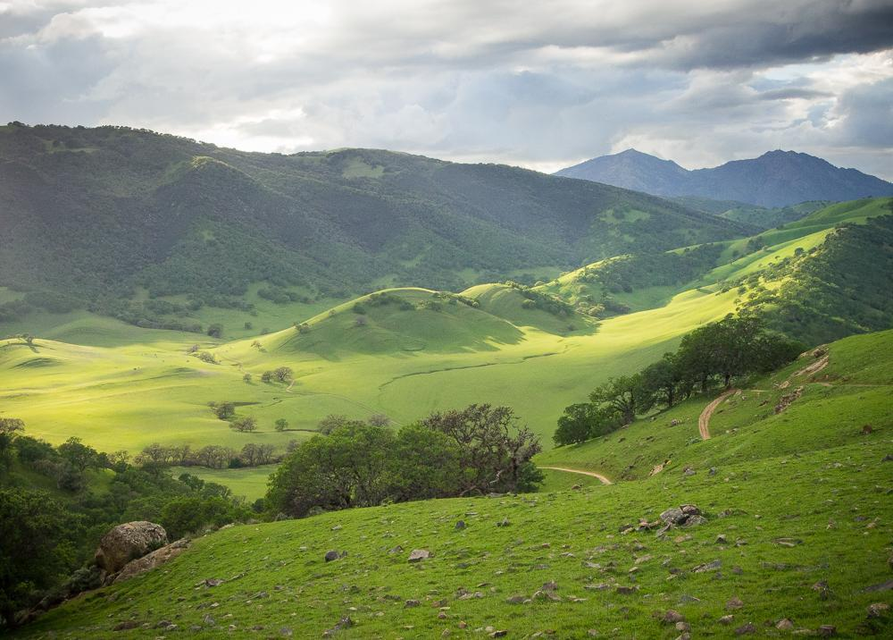

Crossroads Where Tribes Traded, Round Valley, California, 2015 by Sue Reynolds

In the United States, the government passed the Indian Removal Act in 1830, which approved a systematic removal of American Indians from their ancestral lands and sacred sites in order to make the areas safe and available for expanding numbers of European settlers. Before the Spanish and later other Europeans came to claim the part of Northern California seen in the photograph above, it was a crossroads where different tribal groups traded and socialized.

At that time, indigenous tribes and civilizations spanned the continent. As European settlers moved further and further into lands occupied by indigenous peoples, conflicts arose. A complex history of un-ratified treaties resulted in the displacement of tribes from their homelands, sometimes peacefully and sometimes by force. Many tribes resisted and were forcibly removed by the U.S. Army. The Sioux, among others, refused the relocation and confinement orders at first and stood ready to fight. One of the best known conflicts was the Sioux War, between 1876 and 1881, which included the Battle of Little Bighorn in 1876.

A complex history of un-ratified treaties resulted in the displacement of tribes from their homelands, sometimes peacefully and sometimes by force. Many tribes resisted and were forcibly removed by the U.S. Army. The Sioux, among others, refused the relocation and confinement orders at first and stood ready to fight. One of the best known conflicts was the Sioux War, between 1876 and 1881, which included the Battle of Little Bighorn in 1876.

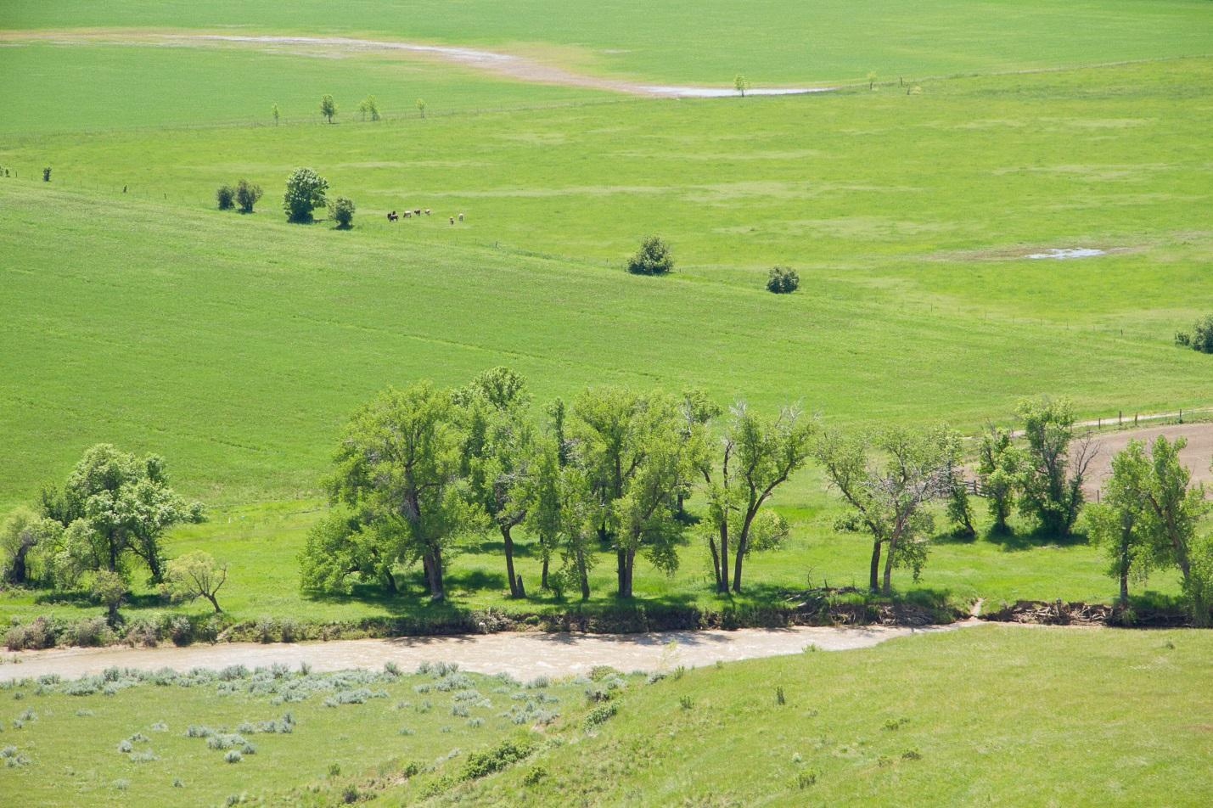

Little Big Horn River, Little Big Horn National Battlefield, Crow Reservation, Montana, 2011 by Sue Reynolds

The Little Big Horn National Battlefield — now a national park — was once the site of fierce fighting between the combined forces of the Lakota, Northern Cheyenne and Arapaho tribes and the 7th Calvary Regiment of the U. S. Army, led by General George Armstrong Custer. The battle, commonly referred to as Custer’s Last Stand, was a huge victory for the Natives. Custer and over 300 of his 700 soldiers and scouts were killed or severely wounded and went on to become folk heroes in American history for some while Crazy Horse and Sitting Bull became heroes for others.

**Note:** Older students can research the Sioux War and the Battle of Little Bighorn in advance to expand the conversation.

**Discussion/Writing Questions**

Who are indigenous peoples?

What does “ancestral home” mean?

Why did the United States Government feel it was necessary to remove American Indians from their ancestral homes and sacred sites?

Do you think this was fair?

How would you feel if you and your family were forced out of your home and moved to a location you were unfamiliar with? What problems might you face in this situation? How do you think you and your family might respond?

Why would Native Americans rather fight than lose their ancestral and sacred sites?

What is a treaty?

Do you think it was fair for the U. S. government to break the promises it made to tribes?

If someone consistently broke promises they made to you how would you feel about that person?

Why do you think the Lakota, Arapaho and Northern Cheyenne tribes joined forces to fight the U. S. Cavalry?

How do you feel about the victory of Native tribes over the U. S. Calvary at the Battle of Little Big Horn?

Many lives on both sides were lost in the forced removal of Native Americans from land the U. S. Government wanted to control. How do you feel about this?

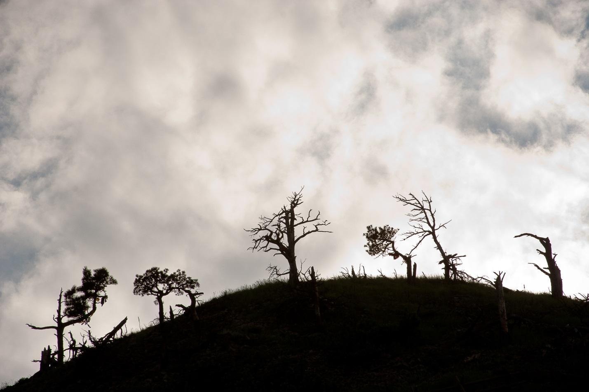

Evening Sky Over Bear Butte, Black Hills, South Dakota, 2008 by Sue Reynolds

Bear Butte, as well as all of the land comprising South Dakota’s Black Hills, are the spiritual home for many tribes across the northern plains, including the Lakota. Today, Bear Butte is a State Park with a portion reserved solely for Native people to use for their traditional ceremonies. In addition, the Bear Butte visitor center exhibits excellent displays of historic religious and related artifacts to help explain the spiritual beliefs and traditions that have been part of this landscape for hundreds, if not thousands, of years.

One summer, while hiking near Bear Butte, photographer Sue Reynolds met a group of teens from the Ft. Berthold Reservation in North Dakota. Their leaders explained that the teens were learning about Lakota star knowledge, apparently a fairly sophisticated astronomy discipline. Sue included a video on Lakota astronomy in the **Additional Resources** **(create link)** section of this Resource.

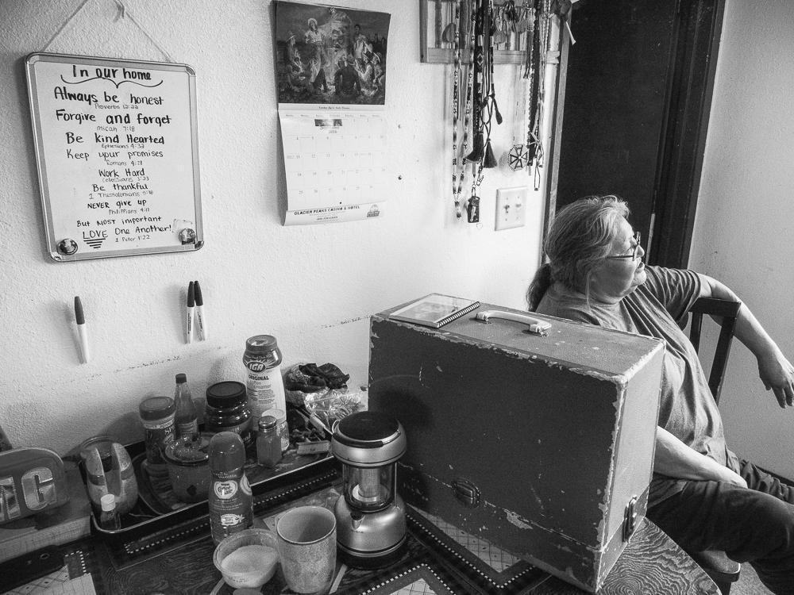

Rebecca Rider, In Our Home Always Be Honest, Heart Butte, Blackfeet Reservation, Montana, 2016 by Sue Reynolds

In her home on the Blackfeet Reservation, Rebecca’s kitchen white board lists the important rules she wants her family to live by: be honest, forgive, be kind hearted and thankful, keep promises, work hard, and, most important, love one another.Rebecca teaches her grandchildren these Christian values, which she says are the same as traditional Blackfeet teachings. She explains that life is hard on the Reservation and that she and others work to prevent bullying, alcoholism and drug use and to focus on education. She practices spelling, vocabulary and writing with her grandson every day.

**Discussion/Writing Questions**

What do you think of Rebecca’s life rules?

Are they similar to how your parents and teachers ask you to live? Explain.

Rebecca feels education is important to her family. Do you agree? Explain.

How does your family help you with your schoolwork?

What is a stereotype? How do you think stereotypes are formed? Where have your ideas about Native Americans come from? What Native American stereotypes have you seen in movies or on television, on the Internet or read in books?

Rebecca’s family is rather poor in material wealth. What is material wealth and what other kinds of wealth are there?

Rebecca’s house and belongings are simple and often old. Sometimes non-Indians living near reservations make fun of or look down on Native Americans because reservations appear shabby or rundown. Do you think this is fair? Discuss.

Do you think Rebecca’s is a positive home? Explain.

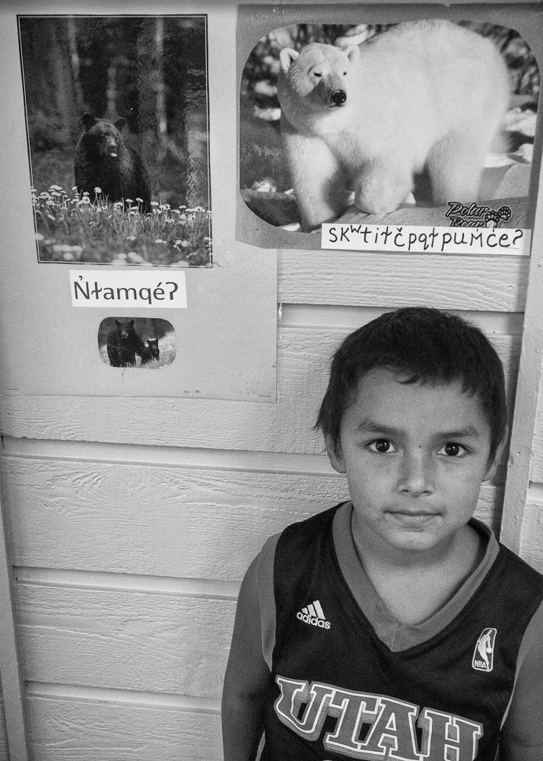

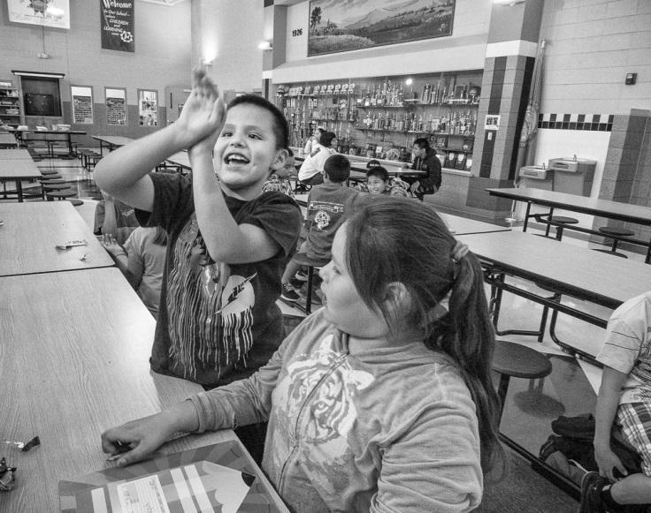

Left: Cory Thompson Shoots Hoops with Lo LaPlant in the After School Program at Wakpala Public School, Standing Rock Reservation, South Dakota, 2015 by Sue Reynolds

Right: Jacob Piapot Learns Salish at NKwsum, Flathead Reservation, Montana, 2014 by Sue Reynolds

**Discussion/Writing Questions**

Describe what looks similar to your school in these photographs of children at school on the Flathead Reservation in Montana and Standing Rock Reservation in South Dakota.

What looks different from what you see at your school?

On the left, Cory is demonstrating his basketball shot to Lo in the cafeteria. What sports do you like to play?

Behind Jacob, on the right, are images of wildlife along with their Salish language names. At Cory’s school English is taught as well as the Native Lakota language. Are non-English or bi-lingual classes offered at your school? If so, what languages are spoken in those classes?

In his poem below, Victor Charlo relates nature to instinct and learning. What things would Native American children learn about themselves from nature? How does the natural world relate to their history and culture?

**Dixon Direction**

Directions are simple here.

Geese know where to go

and eagles fly. Yet sometimes

you get lost on wrong roads.

Then

when you come to school,

you seek from this high window

and find living river, red willow,

white aspen, old Juniper and pine.

This is you.

And bright, clay cliffs fix the stars.

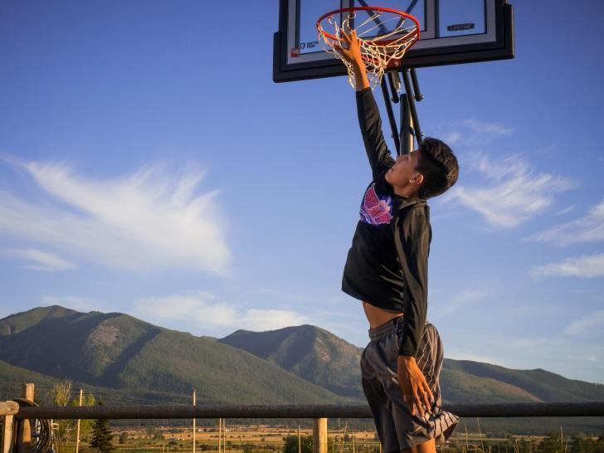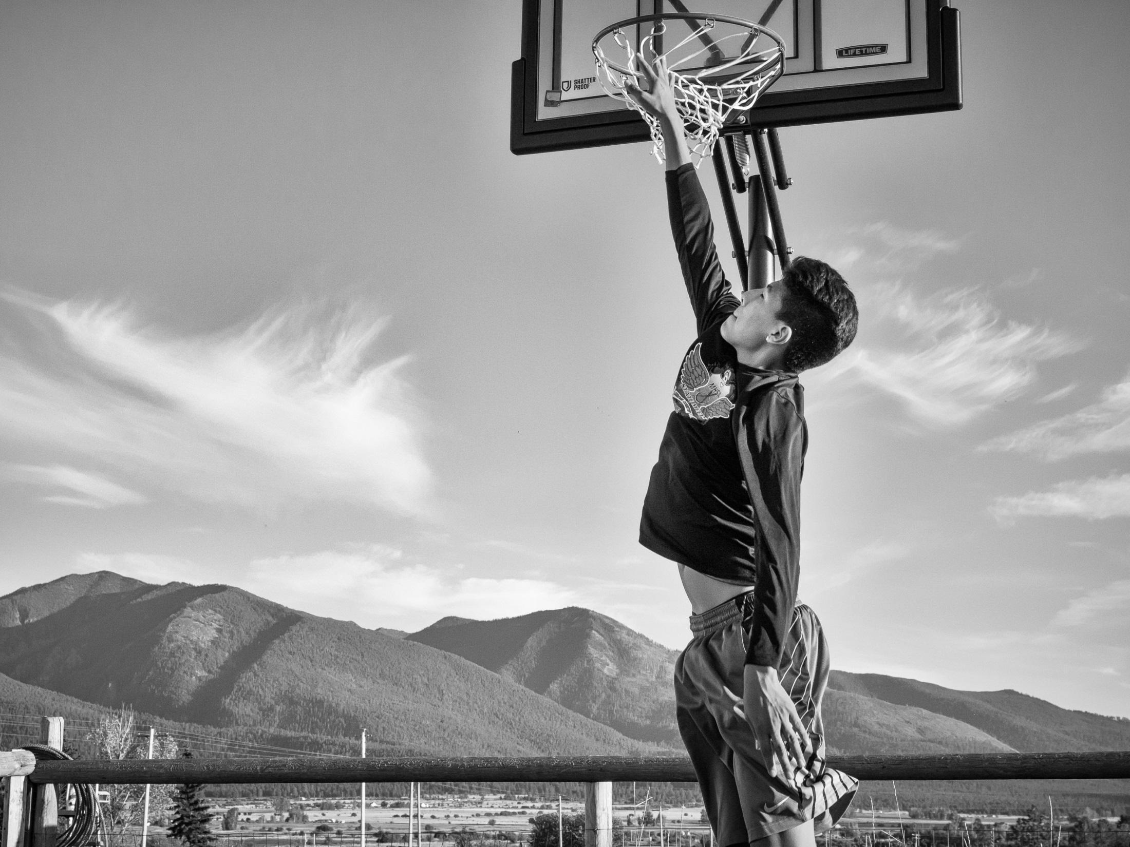

Ivory Brien is Really Good at Basketball, Flathead Reservation, Montana, 2016 by Sue eynolds

Ivory lives on the Flathead Reservation in Montana. He is really good at playing basketball and cross country and loves being part of a team. Sue Reynolds photographed Ivory playing basketball in both black-and-white and color.

**Discussion/Writing Questions**

Which do you prefer, the color photograph or the black-and-white one? Explain.

What do you notice first in the color photograph? Why do you think you noticed this first? What in the photograph invites your eye to move around and take in the details? Explain.

What do you notice first in the black-and-white photograph? Why do you think you noticed this first? What in the photograph invites your eye to move around and take in the details? Explain.

Did you notice something in the color photograph that you did not see in the black-and-white version? Explain.

Did you notice something in the black-and-white photograph that you did not see in the color version? Explain.

(Web designer: create link to and from first page of this section)

**Life on the Reservation: Walking in Two Worlds**

Today, in the United States, thousands of Native Americans live on over 300 Reservations. Many travel off the Reservation for school, work, shopping and recreation.

**Discussion/Writing Questions:**

What do you think it means to walk in two worlds?

Do you think walking in two worlds would be difficult? Explain.

Imagine you were Native American and living on a reservation in the United States. What difficulties might you have both on the reservation and off?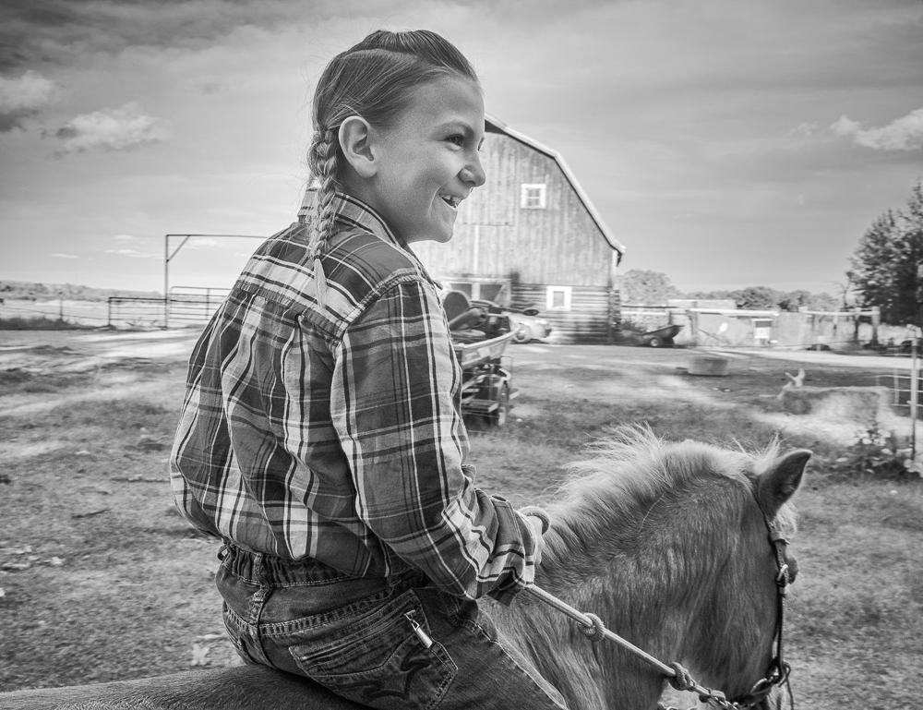

Leo Kipp After a Day Riding to Protect His Grandfather’s Cattle, Browning, Blackfeet Reservation, Montana, 2016 by Sue Reynolds

Leo, who lives on the Blackfeet Reservation in western Montana, spent most of his day with his grandmother, riding his horse around his grandparents’ ranch to protect their cattle from wolves and grizzly bears. Ranchers on the Blackfeet reservation have to protect their cattle from these predators, which follow the herd and kill calves.

Leo wears his hair in the three-braid style that is traditional for Blackfeet boys. His hair and light skin have created problems for him. At a school Leo was attending off the Reservation,

his classmates teased him, saying he was a girl because of his braids. Others said he was not Native American because of his light skin. Because of racial bullying, Leo hit himself and even told his mother he wanted to die. Leo and his family returned to the Blackfeet Reservation, where he attends a language immersion school that teaches in that indigenous language.

**Discussion/Writing Questions**

How does Leo’s situation make you feel?

Have you ever been teased or threatened because you looked, dressed, or talked differently from someone else?

Note: If they are willing, Students can explain being discriminated against.

How did being discriminated against make you feel?

Is bullying a problem in your school?

Why do you think one or more students would bully another student?

Who typically gets bullied?

Who typically bullies others?

Ask students to think about their own actions. Without answering aloud, ask them to consider if they have ever bullied anyone. If they have, what was the reason? Then ask them to consider how they feel about this.

What can you do to help stop discrimination and bullying?

Look at these photographs of life on Native Americans Reservations and find similarities to your own life.

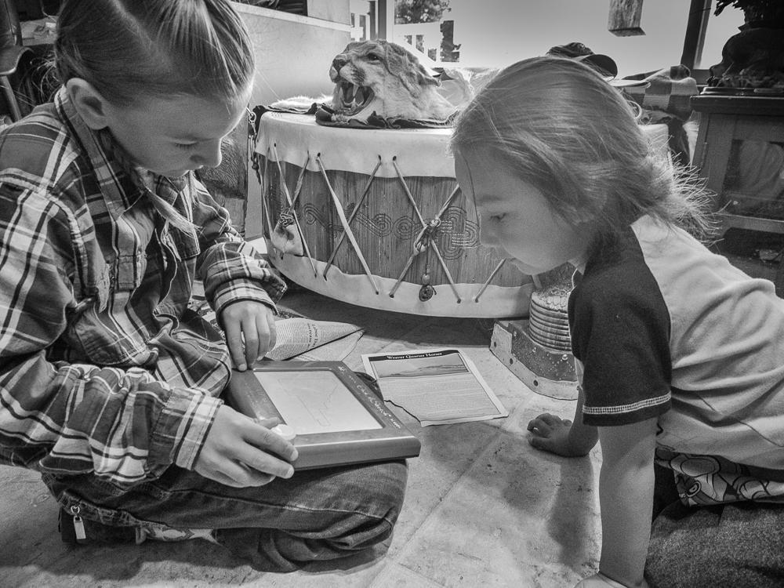

Leo and Rylee Playing Etch A Sketch, Browning, Blackfeet Reservation, Montana, 2016 by Sue Reynolds

Leo and his cousin Rylee play in their grandfather’s living room on the Blackfeet Reservation. The big drum behind them belongs to their grandfather, Joe, who leads traditional religious ceremonies for his Blackfeet community. The drum has been an important means of communicating and celebrating throughout Native American history.

**Discussion/Writing Questions**

What, in this photograph, looks like a typical scene you might see in a house in your neighborhood?

What is different from a scene you might see in a house in your neighborhood? Why do you think the things that are different from what you might have in your own home are in this house on a Native American Reservation?

If you attend religious ceremonies in a church, synagogue, mosque, temple or other location, who leads the mass or ceremony where your family worships? (A priest, rabbi, Imam, etc.)

Do you think religion is important to people of faith? Explain.

Is music part of your family’s religious ceremony? If so, what musical instruments are used and is religious music played and are songs such as hymns sung?

Grandfather Joe did not take part in any traditional Blackfeet ceremonies until he was 17, because until passage of the American Indian Religious Freedom Act (AIRFA) in 1978 it was illegal to practice or perform traditional Native American ceremonies. If discovered doing so, Native people were punished, so many took their religion “underground,” which is why some of their religion still exists today. After passage of AIRFA they collaborated with other tribes whose ceremonies, prayers, songs, dances, and accompanying material culture were still intact in order to rebuild their own lost religion.

How would you feel if it was illegal to practice your family’s religion?

What does it mean to take a religion “underground?”



Gigi Yazzie with Eagle Feather Fan, Montana, 2007 by Sue Reynolds

As a springboard for discussion, lead students through one or more of the **Interpretation Strategies. (create link)**

What do you find most interesting about this photograph?

What do you think this photograph is about?

Gigi is Bitterroot Salish and lives on the Flathead Reservation. Her husband is Navajo – Yazzie is a common Navajo name. Gigi’s ceremonial dance fan is made of many eagle feathers. Under U. S. law, only Native Americans can own eagles and there is a three-year waiting list to acquire an eagle from the National Eagle Repository in Colorado. For most American Indians, eagle feathers are sacred because they believe the eagle flies highest and carries prayers to the Creator, or Great Spirit.

What do you think about the fact that only Native Americans can own eagles?

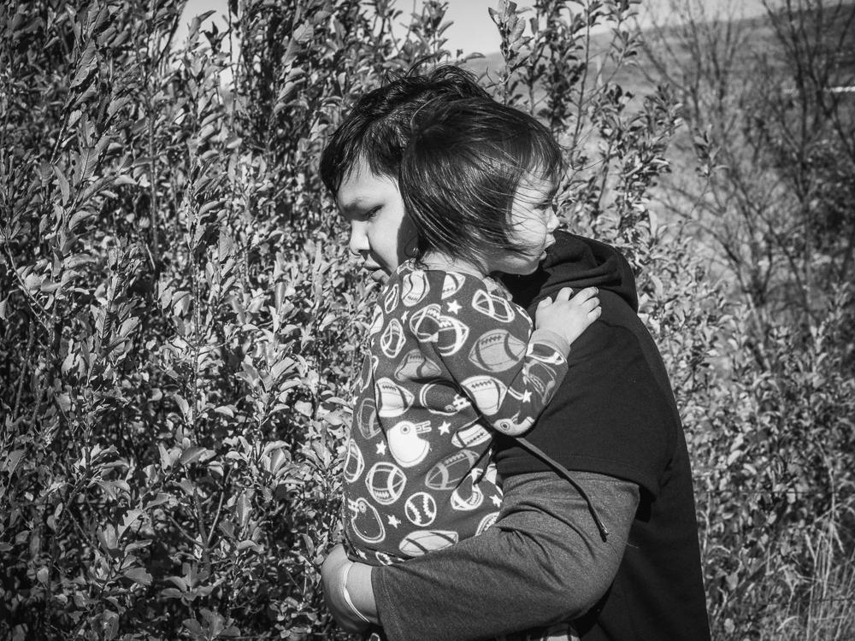

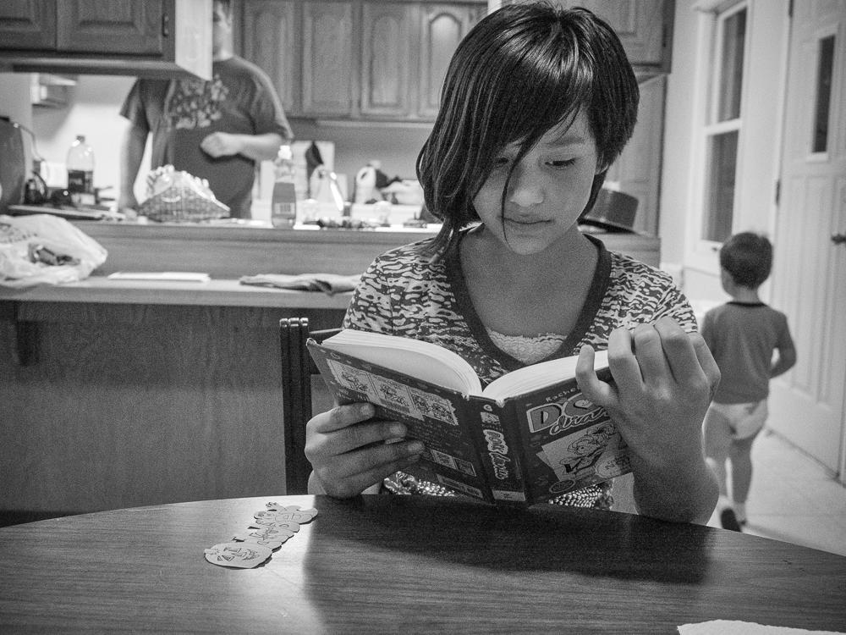

Top: Devin Free Carrying His Little Brother Griffin, Wakpala, Standing Rock Reservation, South Dakota, 2016 by Sue Reynolds

Bottom: Dork Diaries is One of Kiara St. Pierre’s Favorite Books, Mobridge, South Dakota, 2016 by Sue Reynolds

Family is important to Native Americans, both on and off reservations. Lakota teen Devin Free, above top, is very close to his brother. After school and on weekends, he often plays with Griffin, taking him around the family’s yard to explore and play with their dogs and cats. Griffin was adopted as a newborn as his teen mother used drugs so she couldn’t care for him. Devin’s niece, Kiara St. Pierre, above bottom, lives with her parents and brothers across the Missouri River from the Standing Rock Reservation, where Devin lives. Before dinner, she enjoys reading, dancing to Wii and other video games, and playing with dolls, collectible animals and a big doll house.

Historically, many Plains Indians lived in small bands which included extended families so that they could quickly move to follow the buffalo herds which provided them with food, shelter and clothing.

In these large family groups, there were many relatives to help raise the children while the men were away hunting or warring against other tribes. Older relations sometimes adopted children so they could offer their wisdom and guidance to those who needed it.

While Native families today may not live with their extended family -- some live far from their reservations for work and school -- family ties are still strong. Grandparents and other older relatives often raise or help the children. Many extended families gather once a year or more “back home” on their reservations, with their tribe’s powwow being a favorite time to celebrate. When they get together, the elders often tell stories about the family’s ancestors so the younger relatives will know where they come from.

**Discussion/Writing**

What does family mean to you?

Who in your family takes care of you? Do you help care for anyone in your family? Explain.

Does your family gather for holidays, birthdays or other events with relatives whom you see only on these special occasions? What do you do at these gatherings and what do you like best about them?

**Journey**

for Mary Charlo

To come this far would be worth a song

in any other time,

Ride this pass to open country,

country of my grandfathers, of Victor's dust.

This car makes this journey small.

Think of... grandmothers, of great grandfathers, of my children

who count boulders big as bison to headwaters, Three Forks,

on horse or on foot with dogs carrying days

for buffalo, sacred buffalo jump long ago.

Think of tipi like old, gray smoke in trees.

So, sing this time when time is ripe

to break camp, to sing this plain

to thunder again.

Victor Charlo, unpublished (as of February, 2017) manuscript. Note: Vic is checking with his publisher on title and publishing date, for attribution here.

**Discussion/Writing**

This poem includes elements of modern American life, historic Native American life and modern Native American life. Can you identify some of each?

Victor Charlo writes of his ancestors and where they lived. Who are some of your ancestors and where did they live?

Remembering ancestors is very important for Native people and taking one’s family to visit places with tribal/ancestral history on and off reservations is part of Native life. Have you traveled with your family to visit places where your ancestors lived or live? If so, what did you learn about your ancestors? Did your journey make you feel more connected to them?

When you hear stories about your ancestors, what are your feelings about them? How do you feel you are connected to them?

**Note:** This photograph and discussion are suggested for older students.

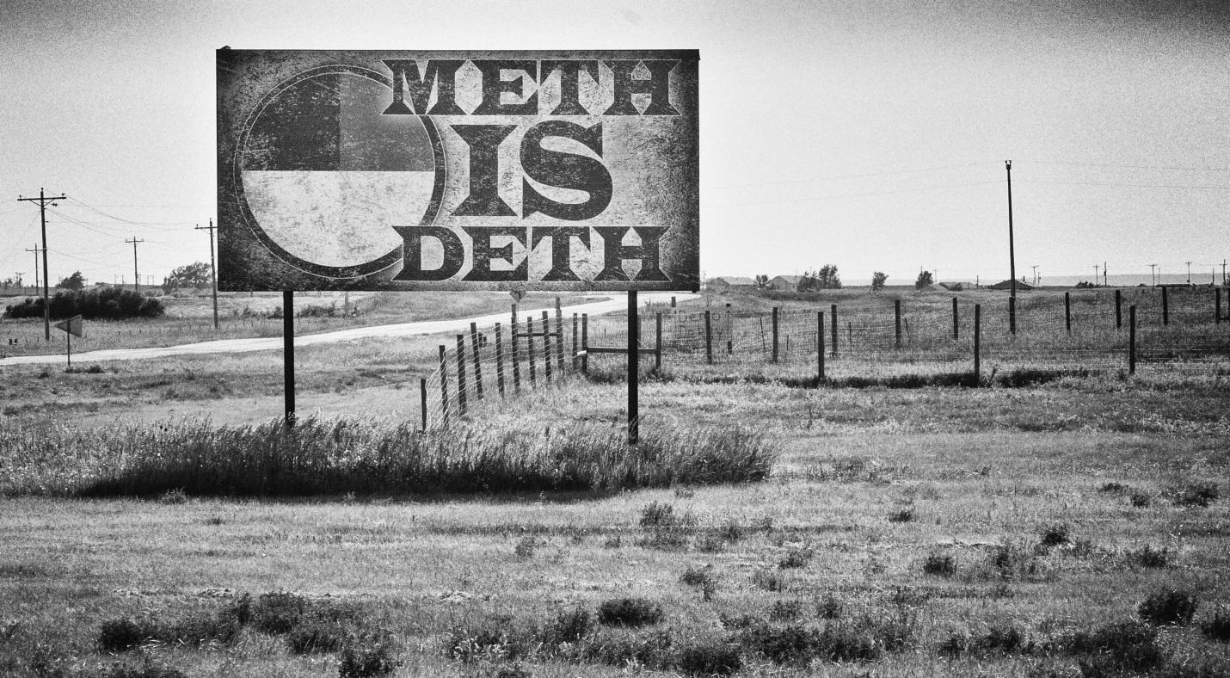

Meth is Deth Sign on Lower Brule Reservation, South Dakota, 2009 by Sue Reynolds

Alcohol and drug abuse are serious problems on Reservations. Poverty, discrimination, unemployment and other hardships add to alcohol and drug use. Select from **Interpretation Strategies** **create link)** to elicit responses to this photograph before continuing discussion.

Programs such as the new afterschool youth program seen in the photograph below help Blackfeet children develop skills and confidence as a way of preventing them from turning to alcohol and drugs. In Joseph’s small community there is little to do after school and programs like this both engage and train them. Children in this program work with a colt over several months to get their horse used to a saddle blanket before putting a saddle on them and finally riding them.

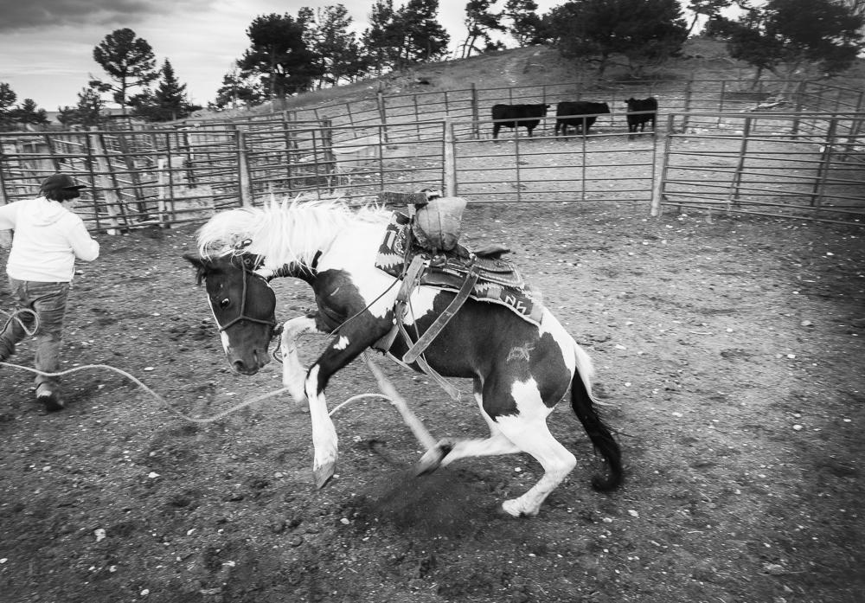

Joseph Chased by a Colt at Tom Crawford’s Youth Program, Blackfeet Reservation, Montana, 2015 by Sue Reynolds

**Discussion/Writing Questions**

Are alcohol and drug use a problem where you live or go to school? Discuss.

While alcohol and drug use are present across the U. S., on Reservations they have become an epidemic. Why do you think alcohol and drugs are such big problems on Reservations?

Are you aware of programs or organizations in your area that help combat alcohol and drug use? Discuss.

Do you feel that engaging children in worthwhile activities at an early age can help them avoid alcohol and drug use? Discuss.

**(create link to/from first page of this section)**

**Reservation Life**

**Current Events: Standing Rock**

The photographs below were taken on the Standing Rock Sioux Reservation in South Dakota.

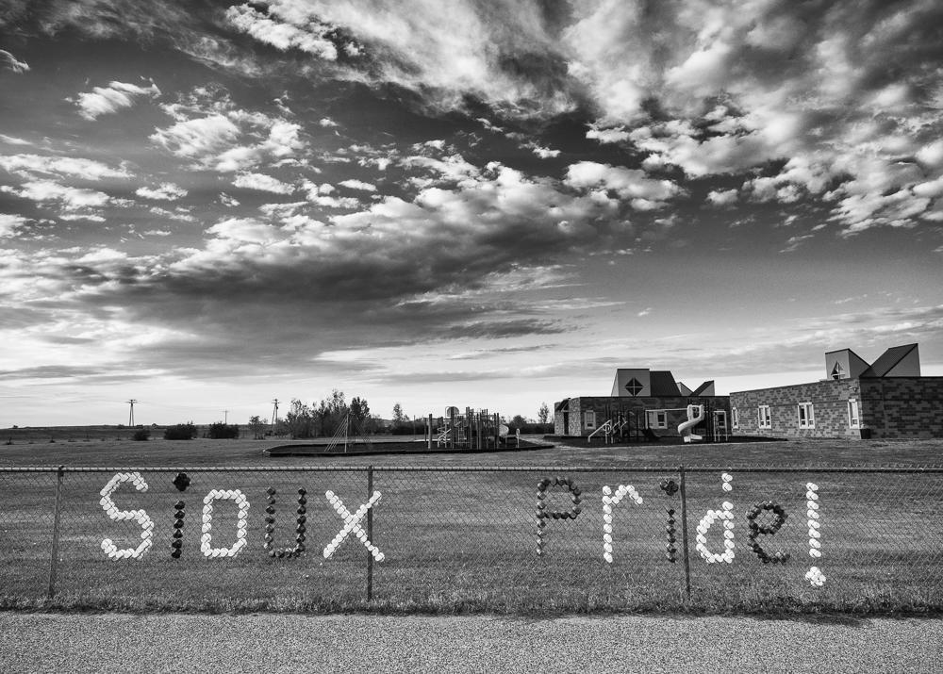

Sioux Pride at Wakpala Public School, Standing Rock Reservation, South Dakota, 2015 by Sue Reynolds

Despite many hardships, tribal identity and pride remain strong. When the Wakpala public school burned down, the Lakota community raised money to build a modern, K-12 grade school. Pride in who they are is important to the Lakota people, especially when negative stereotypes are developed about Native Americans and Reservations by non-Native neighbors.

**Discussion/Writing Questions**

How do you exhibit pride in your school?

How do you exhibit pride in your family’s nationality?

How do you exhibit pride in your country?

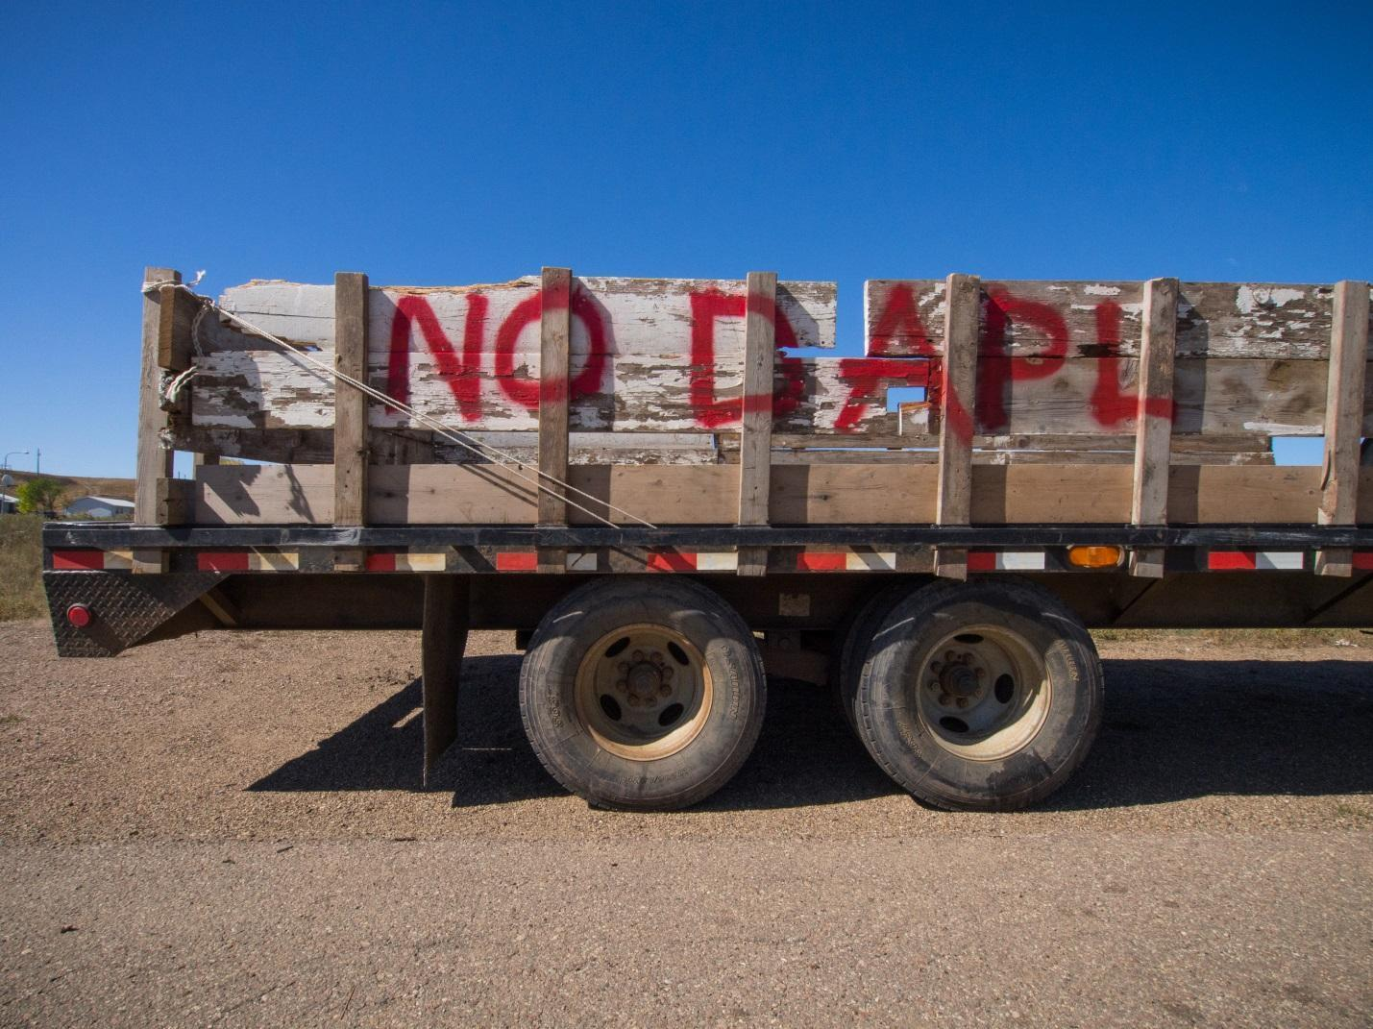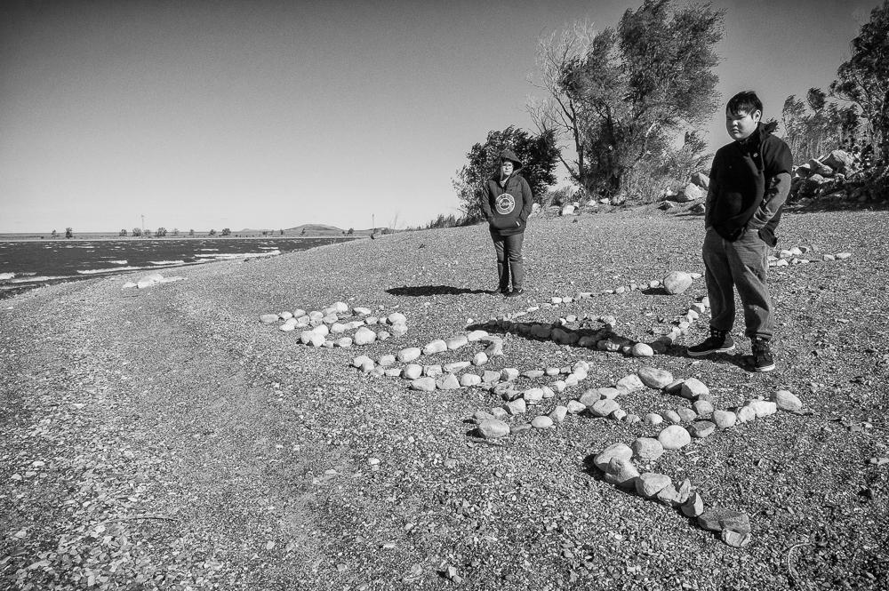

Left: “No DAPL” Protest Truck, Wakpala, Standing Rock Reservation, South Dakota, 2016 by Sue Reynolds

Right: “No DAPL” Sign at Lake Oahe: What’s Our Future? Standing Rock Reservation, South Dakota, 2016 by Sue Reynolds

The hand built and painted signs in the photographs above protest construction of the Dakota Access Pipeline (DAPL) near the water supply of the Standing Rock Reservation. The backstories of these two photographs help set the scene for current protest and conflict between the Lakota Sioux, who live on the Standing Rock Reservation, and the U. S. Government over the pipeline project.

**Note and Discuss**: The protest sign painters of the truck above chose the colors red and white, and photographer Sue Reynolds photographed this scene set against a blue sky. What do these three colors symbolize to you? What statement do you think the colors and subject of this photograph make to the U. S. Government?

In the photograph on the right, Fawn and Devin stand near a “NO DAPL” sign made of rocks on the shore of Lake Oahe on the Standing Rock Reservation. Lake Oahe was created from 1948 to 1959 when the U. S. Government dammed the Missouri River near Standing Rock. Prior to this the Lakota and other tribes lived along the Missouri’s fertile river bottoms, which were abundant with wildlife to feed the people and lush grasses for their horses and cattle. Lakota elders tell stories of Wakpala, which means “Creek” in Lakota. It was an entire prosperous town, which was flooded after the river was dammed and the Lakota people were relocated to higher ground on the plains where the harsher landscape and climate made life more difficult for them.

These photographs symbolize the Lakota people’s uncertain future, the ongoing breaking of promises the Government made to the Sioux regarding their land and resources, and set the scene for discussion of the Dakota Access Pipeline controversy.

**Discussion/Writing Questions**

Is Standing Rock a name that you have heard in the news?

What do you know about the controversy over the proposed location of the Dakota Access Pipeline close to the Standing Rock Reservation’s water supply?

**Note:** To prepare for discussion/writing, older students can research this topic in advance.

Most recently, world-wide attention was drawn to a standoff between the Sioux tribe of the Standing Rock Reservation located in North and South Dakota and the U. S. Government over protection of the Reservation’s drinking water, which comes from the Missouri River. Originally, the Dakota Access Pipeline (DAPL) was scheduled to be constructed near Bismarck, which is North Dakota’s capitol, but Bismarck’s citizens didn’t want the pipeline close to their city because oil pipelines have broken and they feared a break would pollute their drinking water.

To accommodate Bismarck’s concerns, the pipeline’s planned path was moved away from the city. When the new path for the pipeline revealed that it would run under the Missouri River, near the North Dakota portion of the Standing Rock Reservation, which is where the Reservation gets its drinking water, the Lakota Sioux living in the area became alarmed. The Tribe began to protest this several years ago, drafting an online petition to block construction of the pipeline in their area. The Sioux were attempting to protect the source of their drinking water and the preservation of their sacred sites and burial areas against oil pollution that would severely damage the area if the pipeline broke.

As the world watched the Standing Rock controversy, the Sioux were joined by other tribes

and indigenous peoples worldwide, as well as other U. S. and international peoples at several encampments, some sitting directly in the pipeline’s path.

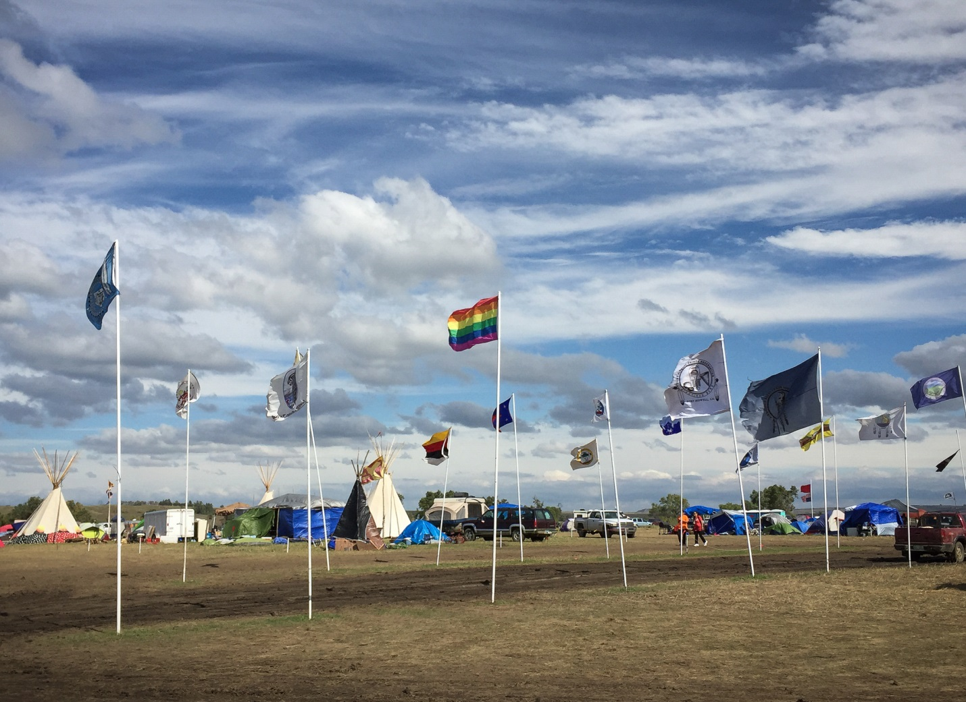

Oceti Sakowin Protest Camp near Cannonball, North Dakota, 2016 by Sue Reynolds

Read through Victor Charlo’s poem below.

**Elder’s Week**

We are Indian.

We make our stand.

But this year we ask elders,

moon, stars, old times

to remind us how we once

were. Drum talks to clay cliffs

that watched our blood ride

before time. How was it?

Songs ring memories

like dark water.

What “stand” could the poem be referring to?

How does this poem relate to Native American History?

How does this poem relate to the Standing Rock controversy?

How does “dark water” relate to Native American history?

How does “dark water” relate to the Standing Rock controversy?

Local law enforcement used rubber bullets and water hoses to try to force people to leave the encampments but failed. Social media and news outlets took up the Tribe’s cause and thousands of people from across the United States traveled to Standing Rock to show their support, bring supplies, or join the encampments. Support groups included U. S. veterans, representatives from Black Lives Matter and many religious organizations, celebrities, every-day Americans and internationals. After the onslaught of support for the Sioux protest, President Obama agreed to pause construction and look for an alternative route for the Pipeline that would not endanger the Reservation’s water supply.

The Sioux and the world remain wary and on alert, as the Standing Rock victory was short-lived. Newly elected U. S. President Trump rescinded the decision to halt construction of the pipeline and find an alternative route, which means resistance and struggle will follow.

**Note:** This current events topic can be researched and followed.

Over much of its history, the U. S. government has lied to, relocated, punished, disrespected, and killed Native Americans and done everything in its power to abolish their religion and culture. Although their history has included many discouraging, horrific and sad events, Native American pride endures.

What is promising is the world-wide support the Sioux received during the 2016 Standing Rock controversy. More Americans, in particular, are standing with Standing Rock and will continue to do so as the pipeline construction plan continues. Progress is never a straight line, but support for Standing Rock and resources such as this can bridge the gap of understanding between Native Americans and non-Natives.

**Discussion/Writing Questions**

What are your feelings about the Standing Rock controversy?

Are there similarities between the Battle of Little Big Horn and the Standing Rock controversy? Discuss.

How does the U. S. Government’s treatment of Native Americans in this controversy make you feel?

What do you think would improve trust and relations between Native Americans and the U. S Government?