**Reclaiming Culture**

**Web Developer: Two links will be created (see links in blue below) to divide this section into two parts: Reclaiming Language and Reclaiming Ceremonies. Links and content for those sections is after the long Introduction text, so it breaks up the section into different segments.**

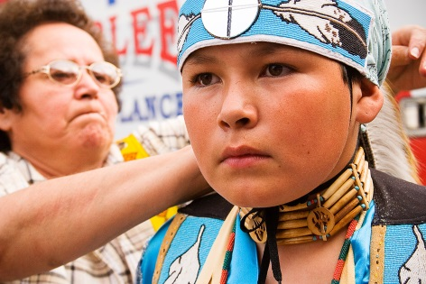

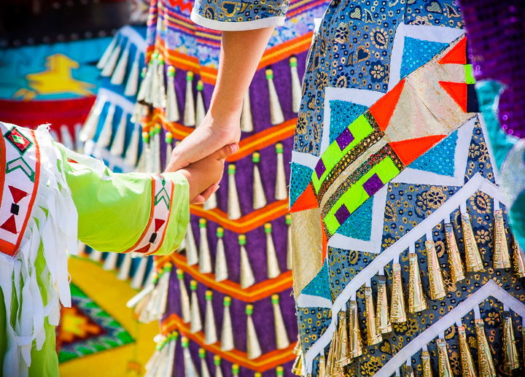

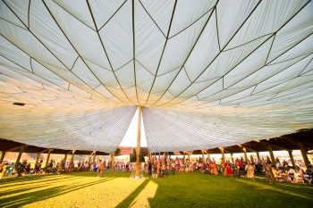

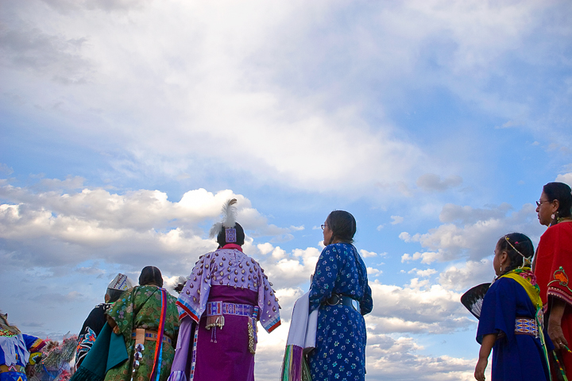

**(Insert small photos side by side to create either a border around this first introductory section or a checkerboard type block of images above or below the text. Web designer can decide how to use the images parired here.)**

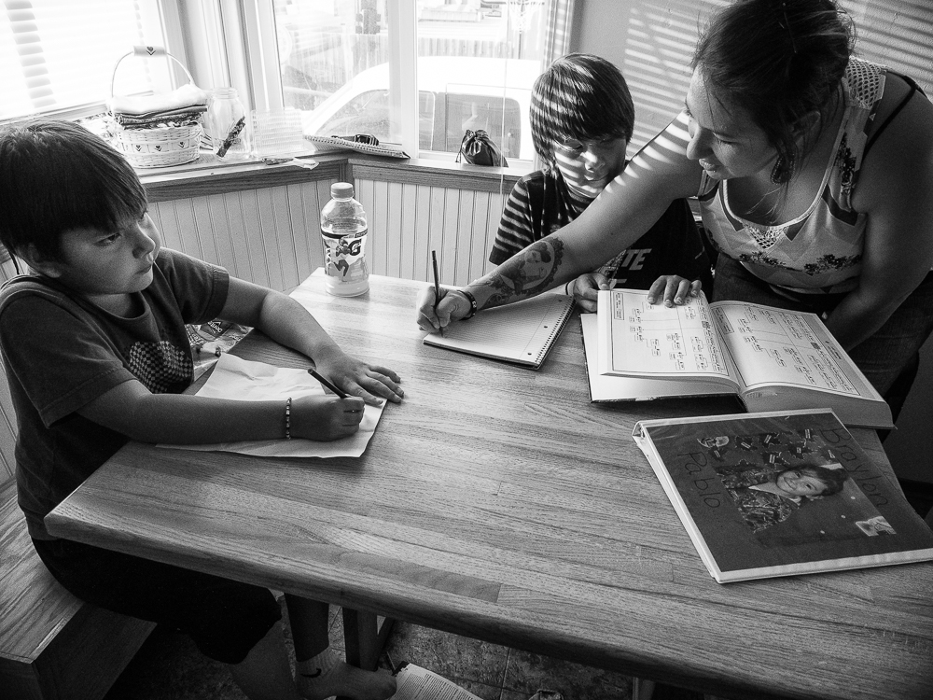

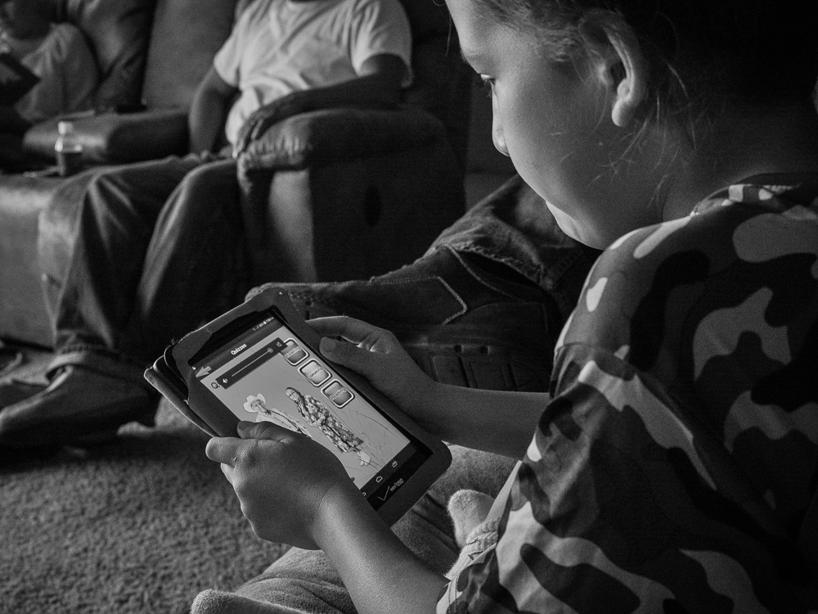

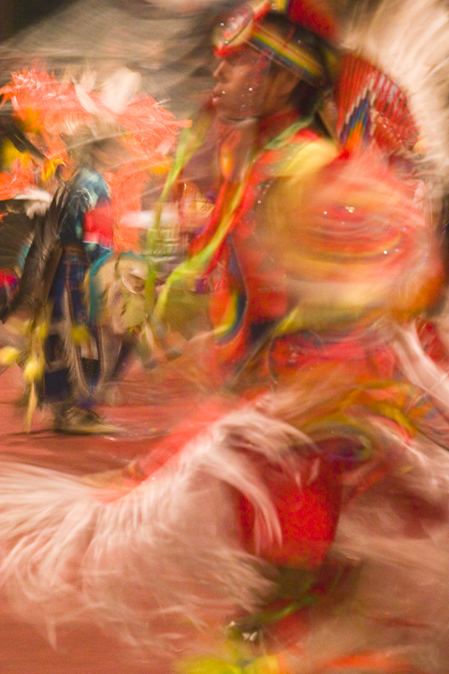

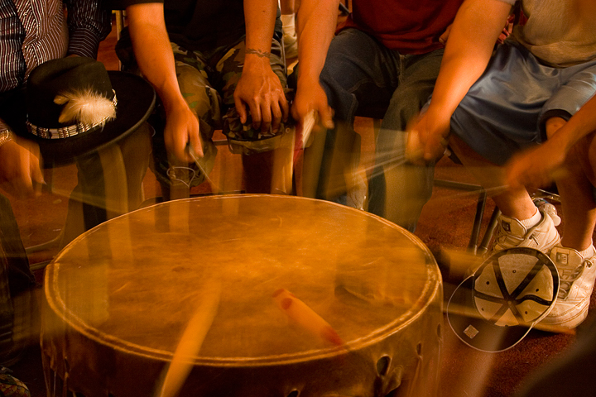

There is a long and complex history of U.S. Government repression of Native American cultural and religious practices, the foundation of which rests on “The Doctrine of Discovery.” This doctrine evolved into international law legitimizing the taking of lands “discovered” where the inhabitants were not Christian. In America, this evolved into the belief of “Manifest Destiny,” which paved the way for Europeans to settle across the United States. **Note:** the practice of “Manifest Destiny” as well as the basic Federal Indian Policy Eras can be researched by older students to add to the conversation.

**(Web designer may want to break up this text with images from the thumbnails as well.)**

In 1883, the Secretary of the Interior began a systematic attack on American Indian traditions when he directed the Commissioner of Indian Affairs to forbid dances and feasts, many of which were central to Native religious practices. The following year it became illegal for Native Americans to actively promote Indian beliefs or participate in traditional ceremonies. The punishment for disobeying this law was 30 days in prison. The Bureau of Indian Affairs went on to deny rations to American Indian men who refused to cut their hair or wore face paint. **Note:** the rules of the Court of Indian Offenses can be researched by older students for writing or discussion.

The Government’s justification for these actions was “Kill the Indian to save the man,” and was a policy of assimilation. Its intention was to re-make the Indian in the European-American mold and its rationale was that it would be better for Native Americans if they looked and acted more like European-American citizens.

The U.S. Bureau of Indian Affairs began establishing boarding schools for American Indian children, often forcing them away from their families for years as an effort of assimilation. At boarding schools, Native children were given European-style clothing and haircuts and they were physically punished for using their native languages or taking part in any traditional religious practices.

Following decades of complaints and demonstrations by American Indians and their supporters, the U.S. Congress passed two important laws that began to reverse the Federal government’s practice of forcing Indians to adopt European culture while abandoning their own traditions.

**Note:** the basic Federal Indian Policy Eras can be researched by older students for assignments and discussion.

The Indian Child Welfare Act of 1978 returned power to tribal governments to keep Native American children in Native homes within the tribe. This law recognized that the high rate of removal of Indian children from Indian homes and culture and into non-Native foster care and adoptions was threatening the existence of American Indian tribes and emotionally damaging Indian children.

Also in 1978, The American Indian Religious Freedom Act was initiated to protect and preserve traditional practices, including religious ceremonies and dances, access to sacred sites, and the possession and use of sacred objects. This law protected the rights of Eskimos, Aleuts and Native Hawaiians as well.

Click this link to explore how American Indians are speaking and teaching their native languages: Reclaiming Language



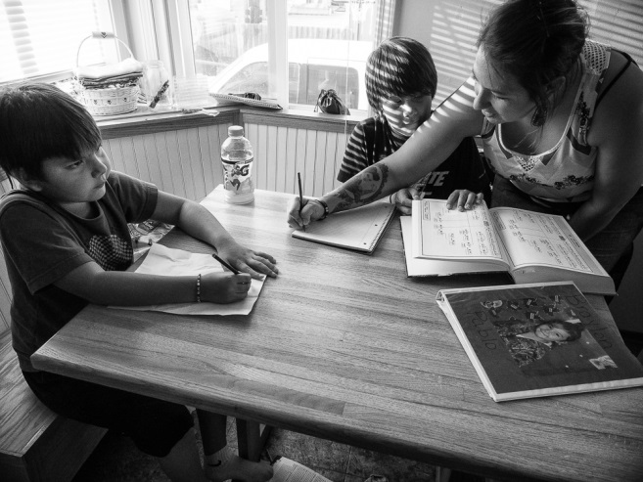

**Left: Nicole Pablo Helping Her Sons with Homework, Flathead Reservation, Montana, 2016 by Sue Reynolds Right: Luke Brien Uses an App to Learn His Crow Language, Arlee, Flathead Reservation, Montana, 2016 by Sue Reynolds**

In the photograph on the left, Nicole helps her sons Talon and his older brother Landon with their homework. They are studying Salish, their native language, which has its own alphabet. The large book is a Salish textbook. Talon and Landon are part of the first generation in a long while that will grow up learning their native language, which helps them understand and be a part of their cultural heritage. Once when Landon went to the county fair, he was called a “cute girl” by non-Natives because, at that time, he wore his hair long. For Native boys and men wearing their hair long in traditional style often causes problems. If they wear it long they face non-Native prejudice and if they cut it, they may be told “You’re not Indian enough,” by other Natives.

On the right, Luke uses an app to learn the Crow language. Luke’s father is Crow and his mother is Blackfeet but they live on the Flathead Reservation in western Montana where few people speak or teach Crow. It is particularly important to Luke’s father that he learn his Native language and he says Luke will understand the importance of this as he grows older. Like many Native languages worldwide, Crow is endangered. On the Crow Reservation in southeast Montana, the people work hard to renew their language through an immersion school, a Crow language dictionary and a language camp for teens.

Across the United States, many American Indian languages have disappeared. Of the estimated 154 Native languages that remain, half are spoken by only a few elders and are not being taught to children. On the Flathead Reservation, there are fewer than 50 fluent Salish speakers.

**Discussion/Writing Questions**

What does the U.S. Government’s motto, “Kill the Indian to save the man” mean to you?

Not so long ago many American Indian children were taken from reservations to live in boarding schools where they were punished for wearing their traditional clothing, taking part in Indian religious ceremonies and speaking their native languages. How would you feel if this happened to you?

Why is having their children learn their tribal language so important to Native American parents?

Do you think it is important for Indian children to know their Native languages? Explain.

Does anyone in your family speak another language? Explain.

Have you ever tried to learn another language? If so, who helped teach you the language? Do you think it’s difficult to learn another language? Explain.

**Note:** Older children can research Native American language programs in your area to add to the conversation.

Long hair is a source of pride and tradition for Indian men and boys, yet it has caused prejudiced remarks and actions. Why do you think this happens?

Do you think you would wear your hair long if you were an Indian boy? Discuss.

The poem below by Salish poet Victor Charlo describes his attempts to speak Salish, the native language of his ancestors.

**The July, 1994**

My Salish synapses firing the old Salish sounds as I try to Talk perfect English to the Dame of Arlee Pow-Wow I’m not doing good so I talk faster and faster Trying to get a solid accent of some kind down Not doing so good. My grandfathers spoke wonderful word In fire, in sky, in wind, in rain, In the heart of the chase.

What are synapses?

How does the poet feel about his ability to speak Salish?

Why does he relate the Salish language to nature and his family’s traditions?

Why would he like to speak Salish effortlessly, as his grandfather did?

Click this link to explore how American Indians are celebrating their religious and cultural ceremonies:

Reclaiming Ceremonies

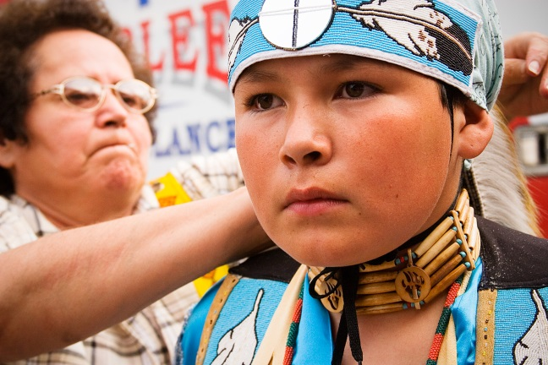

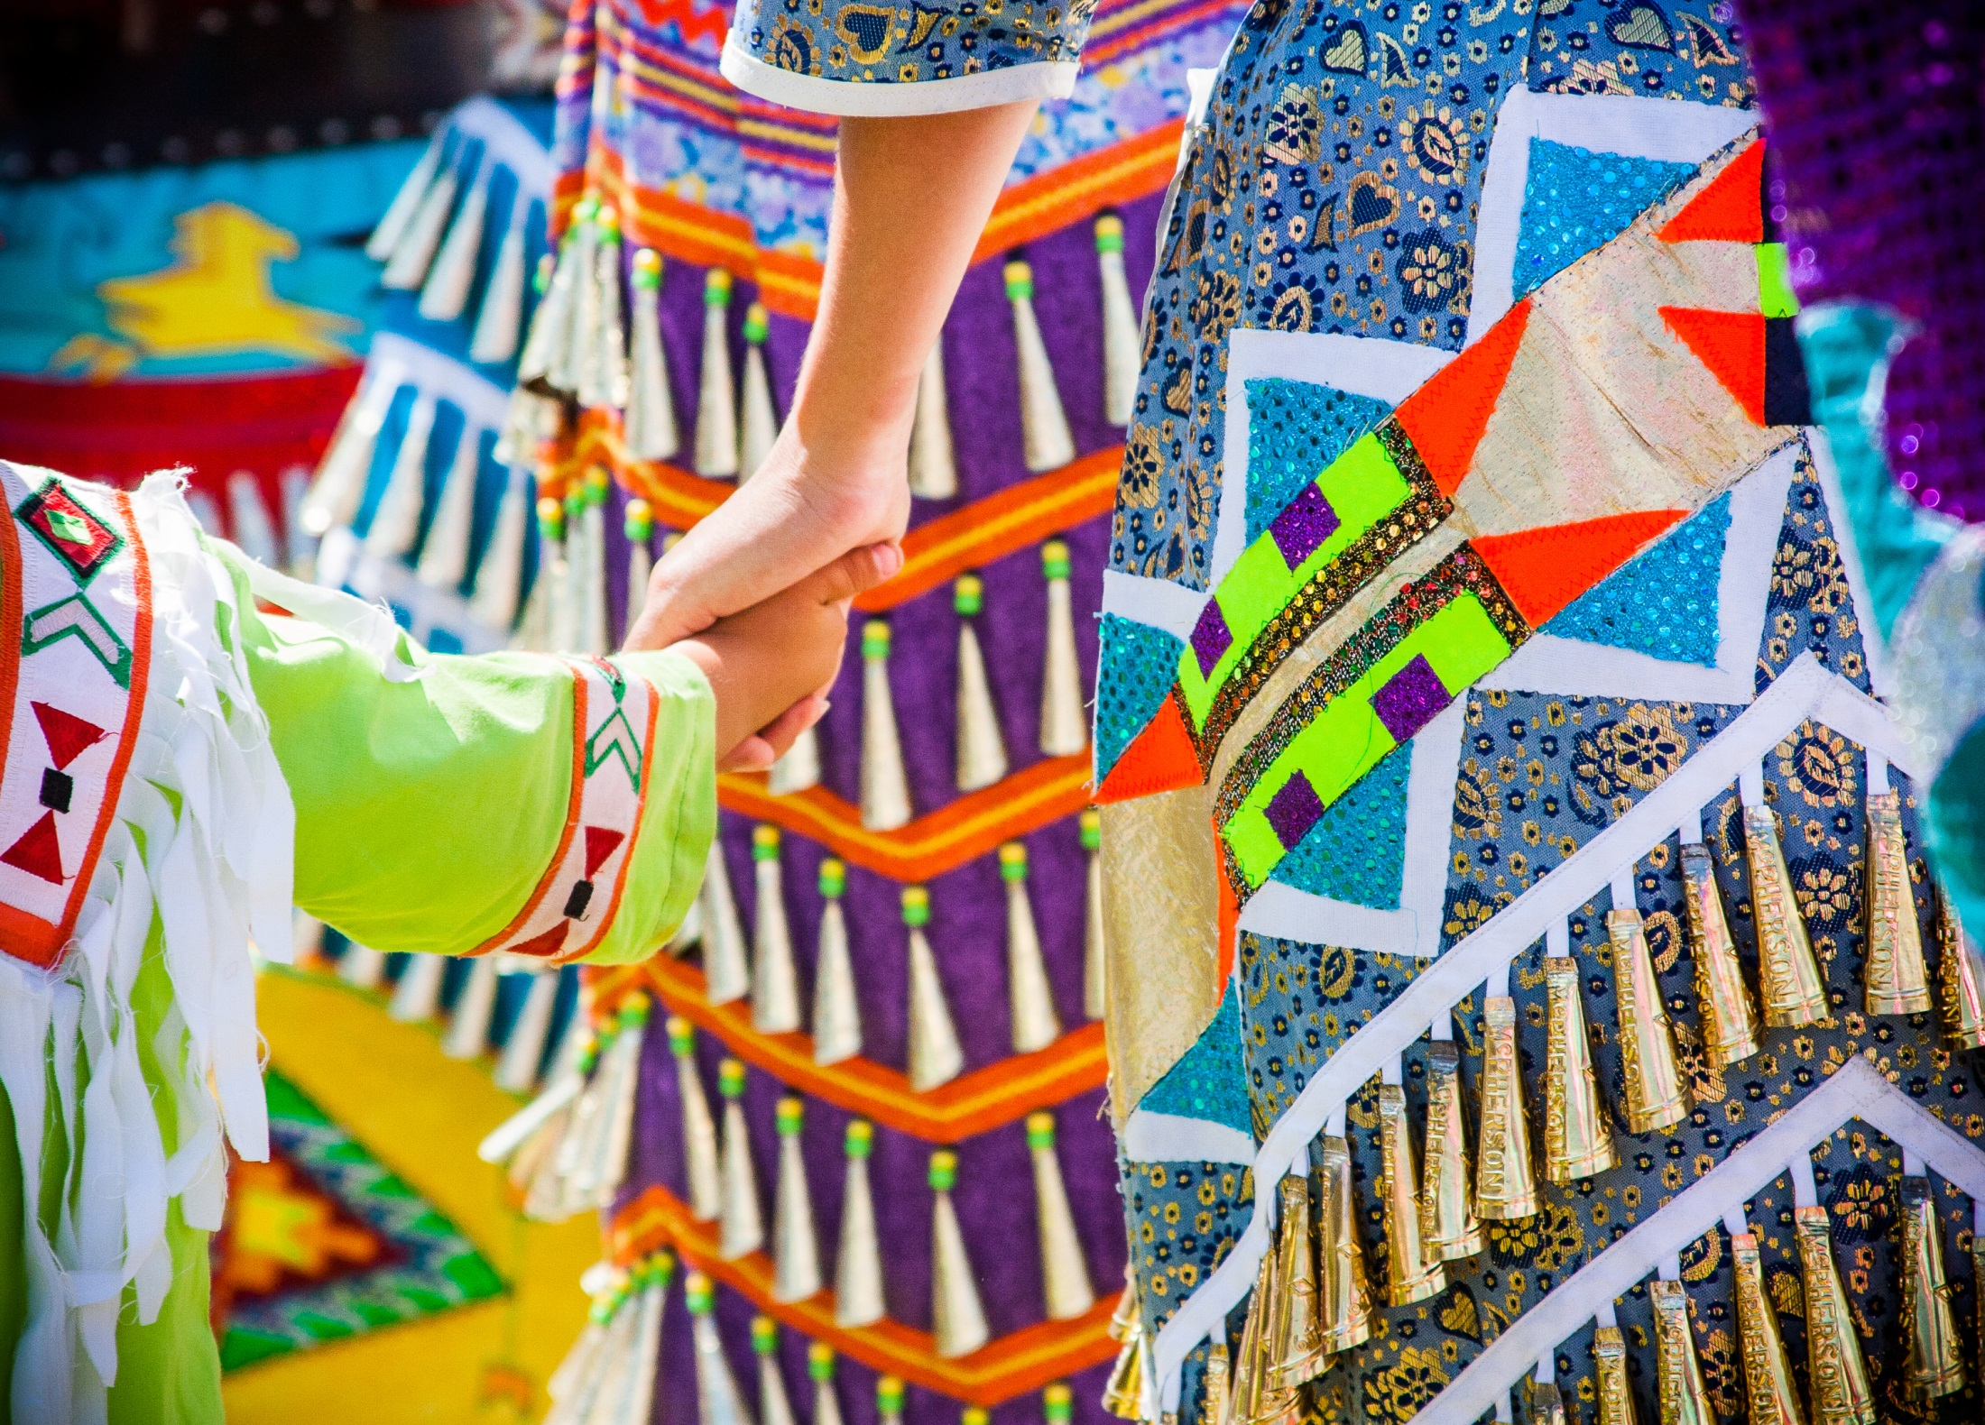

**Left: Joe Pizereau Getting Ready with Grandmother Rose, Montana, 2008 by Sue Reynolds Right: Mother and Child, Rocky Boy Reservation, Montana, 2010 by Sue Reynolds**

Photographer, Sue Reynolds first met Joe, seen on the left, above, at the Arlee Celebration, or powwow in 2006. Joe is getting ready to dance, as his ancestors did, to celebrate their culture. Dancers wear colorful, intricate regalia (outfits), including beaded and feathered clothing, which has been given to them by their families, and which represents hundreds of hours of craftsmanship. Rare eagle feathers are sometimes given to honor a dancer’s achievements and/or service to their community.

At the Arlee Celebration, Sue Reynolds noticed that Joe stood out among the junior Traditional Dancers for his intense concentration, beautiful outfit and straightforward manner. Two years later, again at the Arlee Celebration, Joe remained intently focused as his grandmother helped him get ready to dance.

**Discussion/Writing Questions**

How would you describe Joseph’s presence and attitude?

Why do you think he looks so serious?

Does your family teach you about your heritage? Explain.

Does your family’s religious and cultural heritage include special clothing for certain events? Explain. If so, where does the clothing come from and when do you wear it? Explain.

Does your family’s religious and cultural heritage involve traditional ceremonies or rituals? Explain. If so, where do these take place? Who teaches you what to do and how to do it in order to take part?

On the right we see two beautifully-outfitted dancers holding hands. What do you see that tells you about who they might be?

What do you think they are going to do?

The photograph on the left is what is referred to as a documentary photograph: It clearly documents or records what is happening and to whom. The photograph on the right is referred to as a fine art photograph or image because it comes in close, giving you only part of the story and the subject, as it focuses more on overall design elements like colors, lines and shapes. Even though the two photographs are very different, what similar thing is happening in each photograph? Do you think one photograph tells the story of an older family member teaching a younger one better than the other one? Explain.

Do you prefer the documentary style photograph on the left or the art photograph on the right? Explain.

Powwows can last from one day to a week and take many months to organize. Dance arbors such as this large arena in the photograph, bottom left, are semi-permanent or permanent structures that are considered sacred space because of the traditional singing, drumming and dancing that takes place inside.

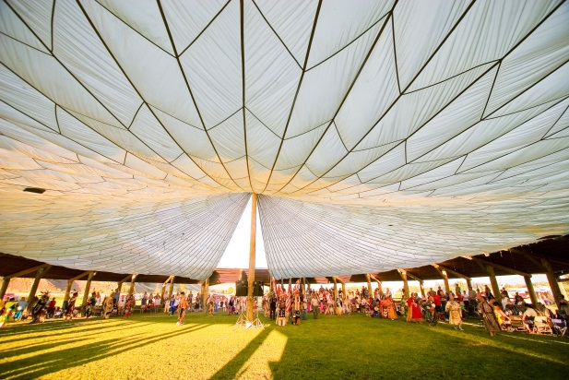

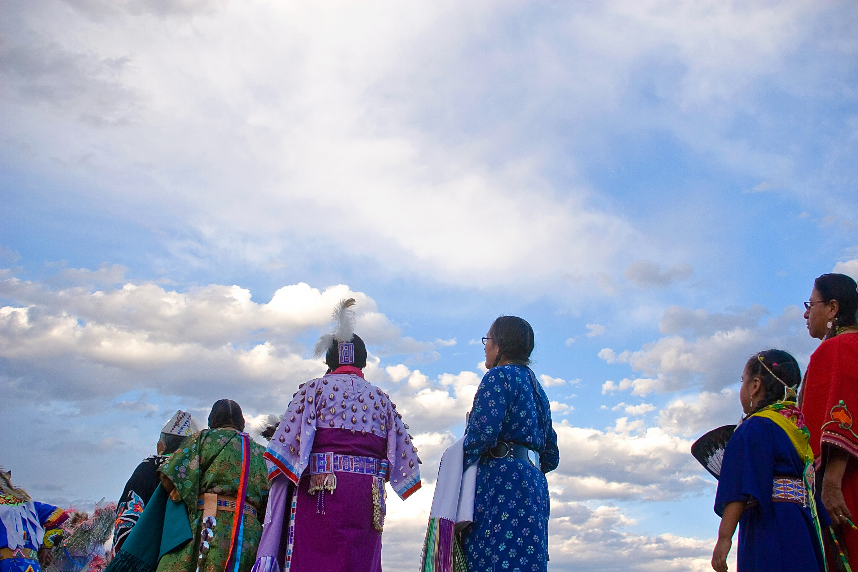

**Left: Grand Entry, Tamkaliks Celebration, Wallowa, Oregon, 2006 by Sue Reynolds Right: Women Under a Big Sky, Crow Reservation, Montana, 2010 by Sue Reynolds**

The line of brightly dressed women on the right are part of the evening session’s Grand Entry, when all dancers gather at the entrance to the arena where, accompanied by singing and drumming, they parade into the dance arbor. The Grand Entry for many tribes is the East entrance, where the sun rises. Many Native Americans consider the dancing, singing and drumming in the arena to be praying. They do this for family members in need and/or for the whole community. They are also celebrating life.

These women have just entered Crow Fair’s large dance arbor as the sun is setting. Crow Fair is one of the largest attended U.S. powwows in Indian Country, and the dancers and drums (drum groups who sing while drumming) come to Crow Fair from all over the West, including western and central Canada.

**Discussion/Writing Questions**

IF you are not an American Indian or do not live near an Indian reservation, where has your information about Native Americans come from?

Were you aware of Indian powwows before discussing them in class? If so, what did you think a powwow was and what did you think happened there?

What surprising thing did you learn about Native American powwows from this discussion?

Why do you think the entrance to the powwow arena faces East, where the sun rises?

Why do you think the arena where American Indian dances, singing and drumming takes place is considered sacred?

Would you like to attend a powwow?



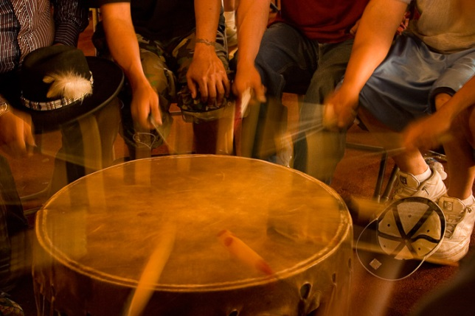

**Left: Blurred Drum Beats Circled, Flathead Reservation, Montana, 2008 by Sue Reynolds Right: Red Fancy Dancer, Arlee Celebration, Montana, 2006 by Sue Reynolds**

Use the # interpretation lesson (create link to Interpretation Strategies to begin discussion and elicit one or two word descriptions of both photographs above. Create group or class poems from students’ responses.

**Discussion/Writing Questions**

Native people say the powwow drum is the heartbeat of Mother Earth. What do you think that means?

Do you think of the earth as a living entity as American Indians do?

This drum, like many, is ringed by men who sing traditional tribal songs while drumming. Do you think it’s necessary to show people’s faces in photographs in order to tell the story of what they are doing?

This photograph is another example of the photographer coming in close to isolate and draw attention to the main subject, which is the drum, the blurred drum sticks and the participants’ hands.

Imagine the rhythmic beat of the drum urging and accompanying the Fancy Dancer in the photograph on the right as he whirls in the fast style of this dance. The Fancy Dance is one of the powwow’s most colorful and exciting dances. Highly anticipated, it is performed by young men dressed in brilliant regalia, whose stamina allows them to execute intricate or “fancy” footwork at high speed.

To photographer Sue Reynolds, this Fancy Dancer is the spirit of joy and transformation at the heart of contemporary powwows. How does her photograph capture the essence of the Fancy Dance?

Share one or both poems below by Victor Charlo. “Mobility” is suggested for all grades.

MOBILITY

Indian youth are too mobile. They flow and flow. We see them afraid As we hit hard times. They laugh one day And the next the fear of God has them shaking. I fear their homelessness. Dancing Boy, you have your mountain. Sing me a brave song.

**Discussion Questions**

In this poem Victor Charlo urges Native youth to connect to the traditions their people find sacred and powerful. What fears has he shared about their lives that lead him to suggest this?

When the poet states he fears their homelessness what do you think he means?

Why does he think traditional singing and dancing will help Native youth?

Charlo’s poem, “Rebellion,” is suggested for older students.

REBELLION

Chokecherry leaves are red, money trees quake a young grasshopper green. Bark dazzles you like the snow vest on dancing boy as apples so good are gone Outside the kitchen window Beyond right through that narrow passage. Jocko, who is going to teach me to dance? Should I ask the dancing boy to show me how? Knees bent, legs raised, arm up, ribbons Flowing in the wind, eagle feathers, dancing, dancing.   
They ask me to go to Wounded Knee But I say I am helper here at home and I have to tend to the garden. They agree, for people have died at Wounded Knee, And it is time that they come home. I am home, that is all the wisdom I need to know. For now, White bird dancing. Everyone should have a place at least once in their life that is secure, where they can Come and go as freely as they want, Break camp, dancing boy, you have the mountain.

Read the poem to your students and then read it again slowly, or share the written version. Ask students what words or phrases the poet includes that relate to:

The colorful regalia worn for celebration ceremonies, how it relates to and comes from nature.

What the poet is seeking. Why do you think he wants to be taught to dance?

How he evokes the past. **Note:** older students can research Wounded Knee to continue this discussion or you can explain that it was an historic massacre that killed many American Indians.

How he describes the dancer and his movements.

What he believes the dancer can summon from his ancestors.

What have you learned about Native ceremonial dances from Victor Charlo’s poems?

**Resources:**

Arlee Celebration web site: [www.arleepowwow.com](http://www.arleepowwow.com) Crow Fair web site: [www.crow-nsn.gov/crow-fair-2016.html](http://www.crow-nsn.gov/crow-fair-2016.html) Heart Butte Indian Days powwow: <https://www.facebook.com/Heart-Butte-Indian-Days-HBSC-197287083619699/> Lakota powwow calendar: : <https://www.travelsouthdakota.com/before-you-go/about-south-dakota/plains-indians/powwows-celebrations> American Indian Tribal Directory Website: <http://tribaldirectory.com/> Rules Governing the Court of Indian Offenses: <https://rclinton.files.wordpress.com/2007/11/code-of-indian-offenses.pdf>